Memento ViveRe

Team members: Macovei Rares-Stefan

Components

* 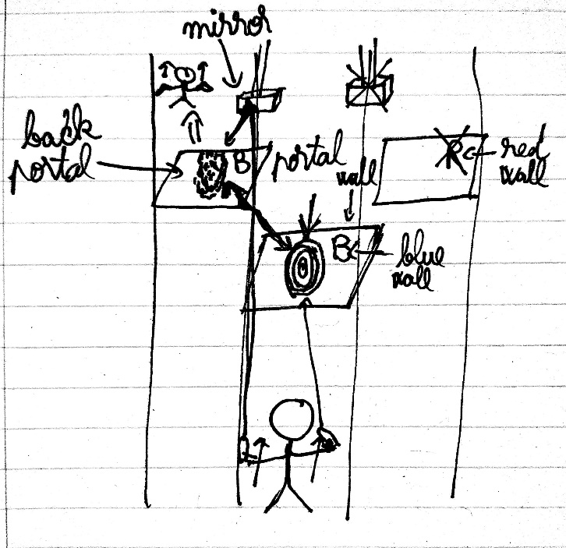A race with color-based obstacles in which the player has to use portals and mirrors to overcome them
* A small puzzle in the middle of each level where different mechanics will be in place:
  + 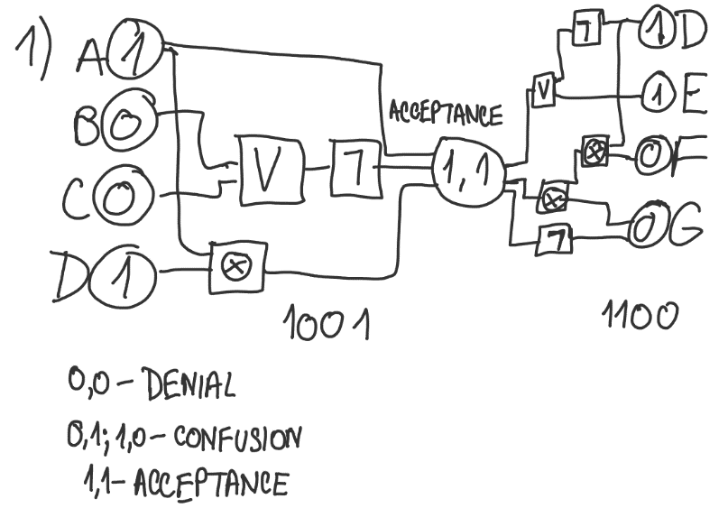Logic Circuit (denial) = changing the binary inputs to have the output of a collection of different logic gates to 1. The solution is unique.
  + 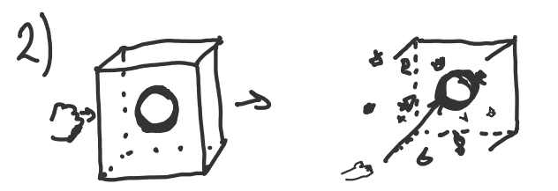Superhot-like puzzle(anger) = glass cube with a heart inside; time moves when the player moves; the player has to punch the cube and then move very slowly to get the heart, as the heart mustn’t be touched by the smithereens (or else you try again). This puzzle doesn’t have a concrete solution; it’s more of a dexterity challenge.
  + 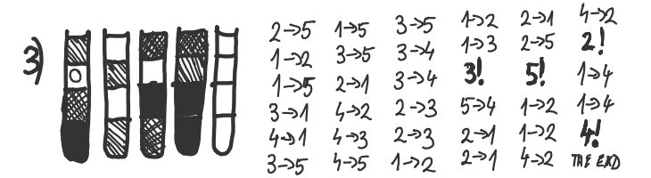Water Sort puzzle(bargaining) – not a unique solution: you can use different tubes for different colors



* + 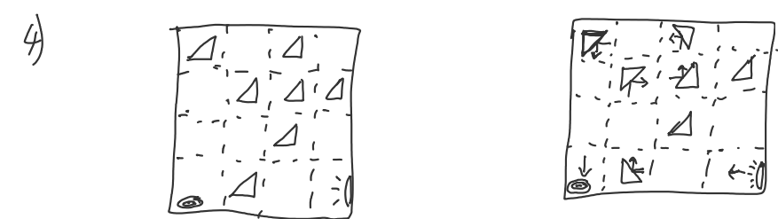Mirrors and Lights(depression) = rotate mirrors so the light beam gets to a target (unique solution)
  + Tetrominoes(a zen experience, signifies acceptance) = place tetrominoes in a rectangle (6x6 square here) to fill it wholly. This can be generated automatically for any rectangle with a number of cells dividable by 4. You choose a cell and then create a path of four cells where all the cells are connected (not necessarily neighbors). The solutions are not unique, as they can be rotated or rearranged.
* 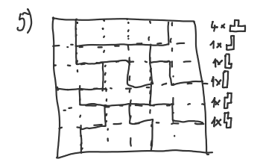An endless race where the pace increases in time

Scenes

* Main menu
* Introduction scene with the Greek gate
* Scenes for the 5 levels
* Scenes for the puzzle in the middle of each level, including night/day cycle (first puzzle starts at night, last puzzle is during the day)
* Scene for finishing the level
* Scene for the endless level

Models

* The abstract void/being that the player is running from
* The Greek gate
* The Greek temple where the puzzles are taking place (and the different lighting for the night/day cycle)
* Black and white environment that turns colored through the level
* Obstacles (walls, spikes, sculptures)
* The three or so lanes where the player can teleport
* The portals
* The portal gun
* The puzzles

Assets

* [Unity Particle Pack](https://assetstore.unity.com/packages/essentials/tutorial-projects/unity-particle-pack-127325)
* [Roman/Greek Environments Bundle | 3D Historic | Unity Asset Store](https://assetstore.unity.com/packages/3d/environments/historic/roman-greek-environments-bundle-264734)
* [Greek Temple Pack | 3D Historic | Unity Asset Store](https://assetstore.unity.com/packages/3d/environments/historic/greek-temple-pack-114537)
* [Greek Statues Set | 3D Historic | Unity Asset Store](https://assetstore.unity.com/packages/3d/environments/historic/greek-statues-set-165265)
* [Portals for VR | VFX | Unity Asset Store](https://assetstore.unity.com/packages/vfx/portals-for-vr-228871)

Animations and sound effects

* The gate at the introduction
* Creating portals
* Going through portals
* Going to the puzzle room
* Breaking glass in the third puzzle
* Light beam in the fourth puzzle
* Finishing the level

Ambiental sounds

* [DEAD STRINGS VOL 5 | Epic Dramatic Violin Epic Music Mix | Best Dramatic Strings Orchestral - YouTube](https://www.youtube.com/watch?v=5CzItIZu3mg&ab_channel=EpicMusicVN)
* [KINGS GAMBIT | Epic Dramatic Violin Epic Music Mix | Best Dramatic Strings by @BrandXMusicOfficial - YouTube](https://www.youtube.com/watch?v=R7ie2x1oiDk)
* [Theseus - The Athenian Hero | Ancient Greek Epic Music - YouTube](https://www.youtube.com/watch?v=gttAK74v5mw&ab_channel=SebastienAngelEpicMusicComposer)
* [Epic Greek Music & Epic Roman Music | Battle, Heroic, War (1 hour) - YouTube](https://www.youtube.com/watch?v=JrtexrCFuVk&ab_channel=BrandonFiechter%27sMusic)

Journey Map

